Name

Mathematics Stage 5 Paths
Expand and Factorise Monic Quadratics

Book 1 |  | Version: 261007  Feedback:  https://MrDingMaths.com
Contents
Syllabus Content 2
Learning Intention 3

Syllabus Content
Expand binomial products and factorise monic quadratic expressions
- Expand binomial products
- Factorise monic quadratic trinomial expressions
- Solve problems involving expansion and factorisation of algebraic expressions

Expanding Binomial Products using the Rule

- Expand Binomial Products using the Rule
- Multiply each term in the first bracket by each term in the second bracket.
- Simplify the result.

$$=\left(a+b\right)\left(c+d\right)$$  $=a\left(c+d\right)+b(c+d)$ $=ac+ad+bc+bd$ | 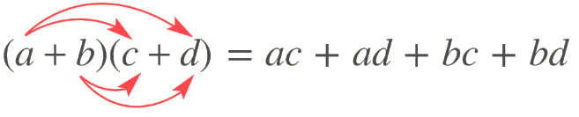  Shortcut:

- Example Expand binomial products
$(x+3)(x+5)$  $\left(x+3\right)\left(x+5\right)=x^{2}+5x+3x+15$  $=x^{2}+8x+15$ | $(x-4)(x+7)$  $\left(x-4\right)\left(x+7\right)=x^{2}+7x-4x-28$  $=x^{2}+3x-28$

- Guided Practice

Expand and simplify these expressions.
- $(x+4)(x+2)$  $$x^{2}+6x+8$$ | - $(x-5)(x-2)$  $$x^{2}-7x+10$$
- $(2x-1)(x-6)$  $$2x^{2}-13x+6$$ | - $(5x-2)(3x+7)$  $$15x^{2}+29x-14$$

- Key Ideas
- We can multiply binomials using the rule:
$\left(a+b\right)\left(x+y\right)=$ $a\left( \right)+b\left( \right)$
$=$ ………………………………………

Foundation
- Expand these expressions.
- $(x+3)(x-4)$  $$x^{2}-x-12$$ | - $(x-6)(x+2)$  $$x^{2}-4x-12$$ | - $(x-2)(x+7)$  $$x^{2}+5x-14$$
- $(4x+3)(2x+5)$  $$8x^{2}+26x+15$$ | - $(2x-3)(3x+5)$  $$6x^{2}+x-15$$ | - $(5x+2)(2x-7)$  $$10x^{2}-31x-14$$
- $(3x-2)(6x-5)$  $$18x^{2}-27x+10$$ | - $(2x+3)(3x-2)$  $$6x^{2}+5x-6$$ | - $(4x+1)(4x-5)$  $$16x^{2}-16x-5$$
- $(5x-2)(3x-1)$  $$15x^{2}-11x+2$$ | - $(3x-2)(2x+1)$  $$6x^{2}-x-2$$ | - $(7x-3)(3x-4)$  $$21x^{2}-37x+12$$
- $2(x+3)(x+4)$  $=2(x^{2}+3x+4x+12)$  $=$  $$2x^{2}+14x+24$$ | - $-2(x+8)(x+2)$  $$-2x^{2}-20x-32$$ | - $-4(x+9)(x+2)$  $$-4x^{2}-44x-72$$
- $3(x+5)(x-3)$  $$3x^{2}+6x-45$$ | - $-3(a+2)(a-7)$  $$-3a^{2}+15a+42$$ | - $4(a-3)(a-6)$  $$4a^{2}-36a+72$$
- $3(2x+3)(2x+5)$  $$12x^{2}+48x+45$$ | - $6(3x-4)(x+2)$  $$18x^{2}+12x-48$$ | - $-2(x+4)(3x-7)$  $$-6x^{2}-10x+56$$

Development
- Compare the expansions of $(x+5)(x+2)$ and $(x-2)(x-5)$.
What's the same and what's different?

The sign of the coefficient of $x$ is different
- A room in a house with dimensions 4 m by 5 m is to be extended. Both the length and width are to be increased by $x$ m.
  - Write an expanded expression for the area of the new room.

$$x^{2}+9x+20$$
  - If $x=3$,
    - Find the area of the new room.
$$56 m^{2}$$
    - By how much the area has increased?
$$36 m^{2}$$

- A picture frame 5 cm wide has a length that is twice the width $x$ cm. :
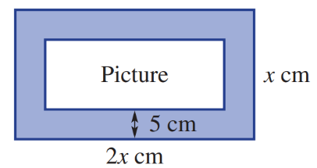

  - Find an expression for the total area of the frame and the picture.
$$2x^{2}$$
  - Find an expression for the area of the picture, in expanded form.

$$2x^{2}-30x+100$$

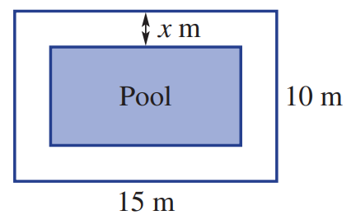
- The outside edge of a path around a rectangular swimming pool is 15 m long and 10 m wide. The path is $x$ metres wide.

  - Find an expression for the area of the pool in expanded form.
$$\left(10-2x\right)\left(15-2x\right)=4x^{2}-50x+150$$
  - Find the area of the pool if $x$ = 2.
$$66 m^{2}$$
- Find an expanded expression for the area of the pictures centred in these frames.
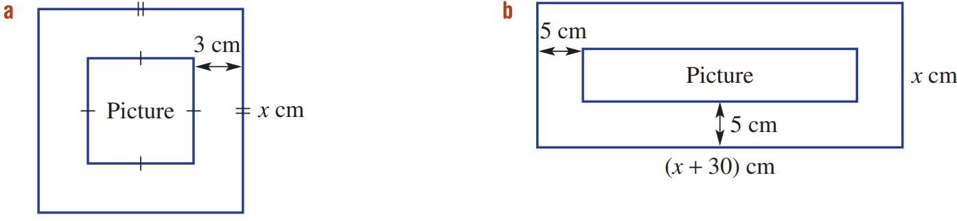  $$x^{2}-12x+36$$ | $$x^{2}+10x-200$$

- Expand and simplify the following.
- $(x+4)(x+3)+x-4$  $$x^{2}+8x+8$$ | - $3x^{2}+(2x-1)(x-2)$  $$5x^{2}-5x+2$$
- $(x+8)(x+3)+(x+4)(x+5)$  $$2x^{2}+20x+44$$ | - $(y-7)(y+4)+(y+5)(y-3)$  $$2y^{2}-y-43$$
- $(x-5)(x+5)+(x+5)(x+5)$  $$2x^{2}+10x$$ | - $(2a+3)(a-5)-(a+6)(2a+5)$  $$-24a-45$$
- $(x-3)(x-4)-(x+2)(x-1)$  $$-8x+14$$ | - $3-{\left(2x-9\right)}^{2}$  $$-4x^{2}+36x-78$$

- Show, by expansion, that $\left(x+a\right)\left(x+b\right)=x^{2}+\left(a+b\right)x+ab$

Use this fact to find possible values of $a$ and $b$ for these expansions.
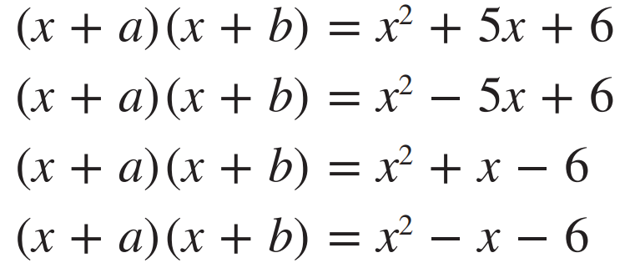  $$\left(x+2\right)\left(x+3\right)$$ | $$\left(x-2\right)\left(x-3\right)$$
$$\left(x+3\right)\left(x-2\right)$$ | $$\left(x-3\right)\left(x+2\right)$$

- Write the missing terms in these expansions.
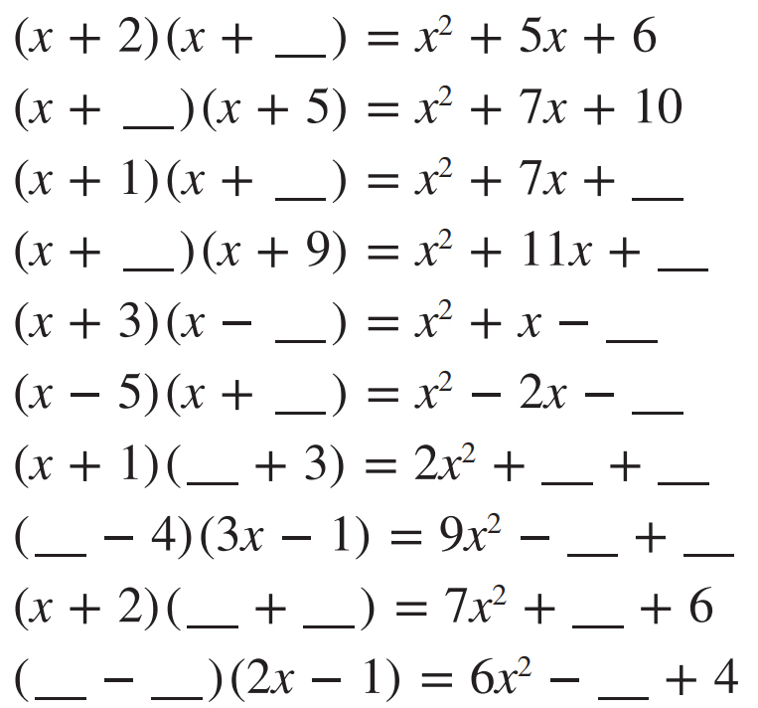  $$3$$ | $$2$$
$$6, 6$$ | $$2, 18$$
$$2, 6$$ | $$3, 15$$
$$2x, 5x, 3$$ | $$3x, 15x, 4$$
$$7x, 3, 17x$$ | $$3x, 4, 2x$$

- Using the area model, or otherwise, expand these expressions.
- $\left(x+1\right)(x^{2}+x+1)$  $$x^{3}+2x^{2}+2x+1$$ | - $\left(x-2\right)(x^{2}-x+3)$  $$x^{3}-3x^{2}+5x-6$$
- $\left(2x+1\right)(2x^{2}-x+4)$  $$4x^{3}+7x+4$$ | - $(x^{2}-x+1)(x+3)$  $$x^{3}+2x^{2}-2x+3$$
- $({5x}^{2}-x+2)(2x-3)$  $$10x^{3}-17x^{2}+7x-6$$ | - $(2x^{2}-x+7)(4x-7)$  $$8x^{3}-18x^{2}+35x-49$$
- $(x+1)(x+2)(x+3)$

$$x^{3}+6x^{2}+11x+6$$

Mastery
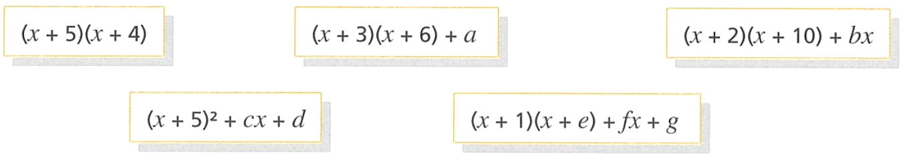
- All these expressions are equivalent. Find the values of all the letters, if possible.

$$a=2, b=-3, c=-1, d=-5$$
$$e=1, f=1, g=19 \left(many answers are possible\right)$$
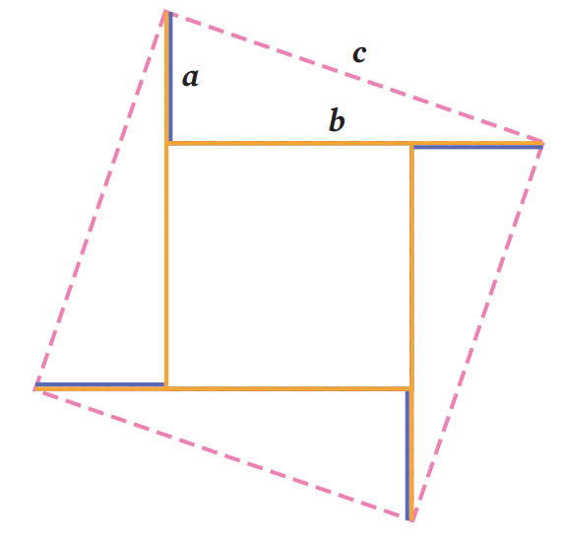
- Four congruent triangles make a square with side lengths equal to $c$.

  - What is the base and height of each triangle?
$$a,b$$
  - Find the area of each triangle.
$$\frac{ab}{2}$$
  - What is the side length of the inner square?

$$b-a$$
  - Find the area of the inner square.

$$b^{2}-2ab+a^{2}$$
  - Write an expression for the combined area of the four triangles and the inner square in terms of $a$ and $b$.

$$a^{2}+b^{2}$$
  - What theorem have you proven?
$a^{2}+b^{2}=c^{2}$
Pythagoras’ Theorem

Factorising Monic Quadratic Trinomials

- Factorising Monic Quadratic Trinomials
- A trinomial is an expression with three terms.
- A quadratic expression has highest power $x^{2}$.
- A monic quadratic has 1 as the coefficient of $x^{2}$.
- A monic quadratic trinomial is an expression of the form $x^{2}+bx+c$

- Identify monic quadratic trinomials
Determine whether these are monic quadratic trinomials.
- $x^{2}+3x+5$ | - $2x^{2}+3x+5$ | - $-x^{2}+3x+5$
- $x^{2}-3x-9$ | - $8+2x+x^{2}$ | - $7+2x-x^{2}$
- $5x^{2}-7x+3$ | - $x^{3}+x^{2}+12x+7$ | - $\left(x+3\right)\left(x-8\right)$
- $\left(x-8\right)\left(x-2\right)$ | - $\left(2x+3\right)\left(x+5\right)$ | - $\left(8-x\right)\left(x+3\right)$

- Rule for expanding $(x+α)(x+β)$
- $\left(x+5\right)\left(x+3\right)=$ | - $\left(x+5\right)\left(x+3\right)=$
- $\left(x+5\right)\left(x+2\right)=$ | - $\left(x+5\right)\left(x+2\right)=$
- $\left(x+5\right)\left(x+0\right)=$ | - $\left(x+5\right)\left(x+0\right)=$
- $\left(x+5\right)\left(x-1\right)=$ | - $\left(x+5\right)\left(x-1\right)=$
- $\left(x+5\right)\left(x-2\right)=$ | - $\left(x+5\right)\left(x-2\right)=$
- $\left(x+5\right)\left(x-3\right)=$ | - $\left(x+5\right)\left(x-3\right)=$
To find the product of two monic binomials $(x+α)(x+β),$
the coefficient of $x$ is ………………… and the constant term is ………
Complete the following:
- $(x+1)(x-12)=$ | - $(x+2)(x-12)=$
- $(x+3)(x-20)=$ | - $(x+7)(x-5)=$
- $\left(x \right)\left(x \right)=x^{2}+7x+12$ | - $\left(x \right)\left(x \right)=x^{2}+3x-10$
- $\left(x \right)\left(x \right)=x^{2}+17x+70$ | - $\left(x \right)\left(x \right)=x^{2}-2x-24$

- Factorising Monic Quadratic Trinomials
To factorise a monic quadratic trinomial: $x^{2}+bx+c=0$:
- Identify the product: $c$
- Identify the sum: $b$
- Think of a factor pair, $α$ and $β$, that has a product of $c$ and sum to $b$.
- Factorise $x^{2}+bx+c=\left(x+α\right)\left(x+β\right).$

- Example Factorise monic quadratic trinomials
$x^{2}-13x+36$ | $a^{2}+12a-28$
  4. $(x-4)(x-9)$ | 1. P: $36$  2. S: $-13$  3. F: $-4, -9$
  4. $(a+14)(a-2)$ | 1. P: $-28$  2. S: $12$  3. F: $14, -2$

- Guided Practice
Factorise these expressions.
- $a^{2}+3a+2$ | - $y^{2}+9y+20$
  $$(a )(a )$$ | P: 2  S: 3  F: ……  $$\left(a+2\right)(a+1)$$
  P: ……
  S: ……
  F: ……
  $$\left(y+4\right)\left(y+5\right)$$
- $x^{2}-7x+12$ | - $w^{2}-2w-8$
  P: 12
  S: $-7$
  F: ……
  $$\left(x-3\right)\left(x-4\right)$$
  P: ……
  S: ……
  F: ……
  $$\left(w-4\right)\left(w+2\right)$$
- $y^{2}-10y+21$ | - $x^{2}-5x-24$
  P: ……
  S: ……
  F: ……
  $$\left(y-7\right)\left(y-3\right)$$
  P: ……
  S: ……
  F: ……
  $$(x-8)(x+3)$$

- Key Ideas
- The expansion of $\left(x+α\right)\left(x+β\right)=$ …………………………
- This means that to “un-expand,” or factorise, we need to find two numbers that sum to the …………………… of $x$ and whose product is the …………………… term.

Foundation
- Fill in the table.
Binomial Product | Expansion | Factors | Sum | Product
$(x+1)(x+3)$ | $x^{2}+3x+x+3$  $=x^{2}+4x+3$ | 1, 3 | 4 | 3
$(x+2)(x+7)$ | $$x^{2}+9x+14$$ | $$2,7$$ | $$9$$ | $$14$$
$(x-3)(x+11)$ | $$x^{2}+8x-33$$ | $$-3,11$$ | $$8$$ | $$-33$$
$(x+12)(x-5)$ | $$x^{2}+7x-60$$ | $$12,-5$$ | $$7$$ | $$-60$$
$(x-2)(x-6)$ | $$x^{2}-8x+12$$ | $$-2,-6$$ | $$-8$$ | $$12$$

- Fill in the table.
Factor 1 | Factor 2 | Sum | Product
$$5$$ | $$7$$ | 12 | 35
$$-5$$ | $$7$$ | $$2$$ | $$-35$$
$$5$$ | $$-7$$ | $$-2$$ | $$-35$$
$$-5$$ | $$-7$$ | $$-12$$ | $$35$$
$$3$$ | $$5$$ | $$8$$ | $$15$$
$$-3$$ | $$5$$ | $$2$$ | $$-15$$
$$3$$ | $$-5$$ | $$-2$$ | $$-15$$
$$-3$$ | $$-5$$ | $$-8$$ | $$15$$
$$4$$ | $$6$$ | $$10$$ | $$24$$
$$-4$$ | $$6$$ | $$2$$ | $$-24$$
$$4$$ | $$-6$$ | $$-2$$ | $$-24$$
$$-4$$ | $$-6$$ | $$-10$$ | $$24$$

- Factorise each expression using the PSF method.
- $x^{2}+3x+2$  P: ……  S: ……  F: ……  $$\left(x+1\right)\left(x+2\right)$$ | - $x^{2}+7x+6$  P: ……  S: ……  F: ……  $$\left(x+6\right)\left(x+1\right)$$
- $x^{2}+8x+7$  P: ……  S: ……  F: ……  $$\left(x+7\right)\left(x+1\right)$$ | - $x^{2}+6x+8$  P: ……  S: ……  F: ……  $$\left(x+4\right)\left(x+2\right)$$
- $x^{2}+3x+2$  P: ……  S: ……  F: ……  $$\left(x+2\right)\left(x+1\right)$$ | - $x^{2}+7x+6$  P: ……  S: ……  F: ……  $$\left(x+6\right)\left(x+1\right)$$
- $x^{2}+10x+16$  P: ……  S: ……  F: ……  $$\left(x+8\right)\left(x+2\right)$$ | - $x^{2}+9x+20$  P: ……  S: ……  F: ……  $$\left(x+4\right)\left(x+5\right)$$
- $x^{2}+3x-4$  P: ……  S: ……  F: ……  $$\left(x+4\right)\left(x-1\right)$$ | - $x^{2}+4x-5$  P: ……  S: ……  F: ……  $$\left(x+5\right)\left(x-1\right)$$
- $x^{2}+2x-15$  P: ……  S: ……  F: ……  $$\left(x+5\right)\left(x-3\right)$$ | - $x^{2}+3x-18$  P: ……  S: ……  F: ……  $$\left(x+6\right)\left(x-3\right)$$
- $x+x^{2}-12$  P: ……  S: ……  F: ……  $$\left(x-3\right)\left(x+4\right)$$ | - $14+15x+x^{2}$  P: ……  S: ……  F: ……  $$\left(x+14\right)\left(x+1\right)$$
- $x^{2}+24+11x$  P: ……  S: ……  F: ……  $$\left(x+3\right)\left(x+8\right)$$ | - $x^{2}-20+8x$  P: ……  S: ……  F: ……  $$\left(x+10\right)\left(x-2\right)$$

- Write the missing number.
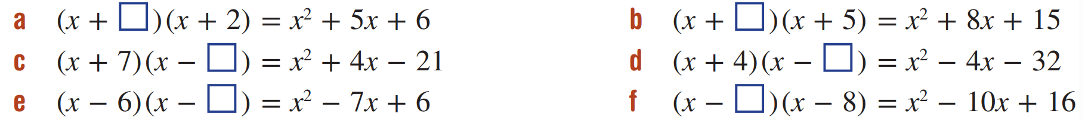  $$3$$ | $$3$$
$$3$$ | $$8$$
$$1$$ | $$2$$

- Factorise each expression using the PSF method.
- $x^{2}-6x+5$  $$\left(x-5\right)\left(x-1\right)$$ | - $x^{2}-5x+4$  $$\left(x-4\right)\left(x-1\right)$$
- $x^{2}-4x+4$  $${\left(x-2\right)}^{2}$$ | - $x^{2}-11x+18$  $$\left(x-9\right)\left(x-2\right)$$
- $x^{2}-5x+6$  $$\left(x-3\right)\left(x-2\right)$$ | - $x^{2}-7x-8$  $$\left(x-8\right)\left(x+1\right)$$
- $x^{2}-5x-6$  $$\left(x+1\right)\left(x-6\right)$$ | - $x^{2}-2x-24$  $$\left(x+4\right)\left(x-6\right)$$
- $x^{2}-x-12$  $$\left(x-4\right)\left(x+3\right)$$ | - $x^{2}-4x-12$  $$\left(x-6\right)\left(x+2\right)$$
- $12-8x+x^{2}$  $$\left(x-2\right)\left(x-6\right)$$ | - $x^{2}+21-10x$  $$\left(x-7\right)\left(x-3\right)$$
- $x^{2}-15-2x$  $$\left(x-5\right)\left(x+3\right)$$ | - $-11x+x^{2}-12$  $$\left(x-12\right)\left(x+1\right)$$

Development
- Match each quadratic expression to its factored form.
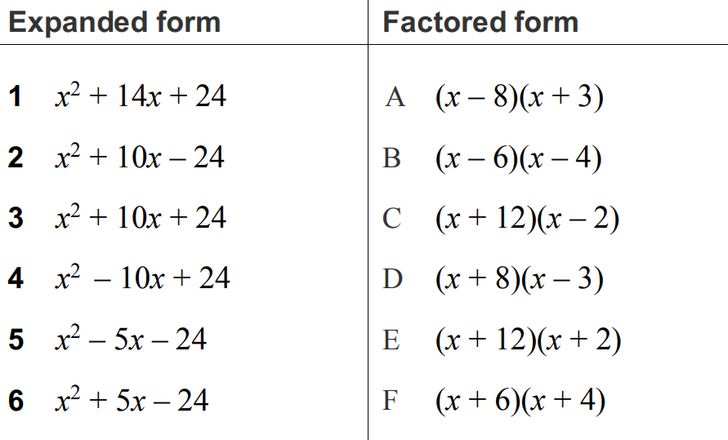

1E, 2C, 3F, 4B, 5A, 6D
- Factorise these expressions. Find product, sum, and factors mentally.
Do not write any working out.
- $x^{2}+13x+36$  $$\left(x+9\right)\left(x+4\right)$$ | - $x^{2}+5x-24$  $$\left(x+8\right)\left(x-3\right)$$
- $x^{2}-13x+36$  $$\left(x-9\right)\left(x-4\right)$$ | - $x^{2}-5x-24$  $$\left(x-8\right)\left(x+3\right)$$
- $x^{2}-20x+36$  $$\left(x-2\right)\left(x-18\right)$$ | - $x^{2}+20x+64$  $$\left(x+4\right)\left(x+16\right)$$
- $x^{2}+20x+36$  $$\left(x+2\right)\left(x+18\right)$$ | - $x^{2}+12x-64$  $$\left(x+16\right)\left(x-4\right)$$
- $x^{2}+15x+36$  $$\left(x+12\right)\left(x+3\right)$$ | - $x^{2}+10x+16$  $$\left(x+2\right)\left(x+8\right)$$
- $x^{2}-15x+36$  $$\left(x-12\right)\left(x-3\right)$$ | - $x^{2}+10x+21$  $$\left(x+3\right)\left(x+7\right)$$
- $x^{2}+37x+36$  $$\left(x+36\right)\left(x+1\right)$$ | - $x^{2}+10x+25$  $${\left(x+5\right)}^{2}$$
- $x^{2}-12x+36$  $${\left(x-6\right)}^{2}$$ | - $x^{2}+6x-40$  $$\left(x+10\right)\left(x-4\right)$$
- $x^{2}+9x-36$  $$\left(x-12\right)\left(x+3\right)$$ | - $x^{2}+3x-40$  $$\left(x+8\right)\left(x-5\right)$$

Mastery
- Factorise these expressions by first taking out a common factor.
- $2x^{2}+10x+8$  $=2\left(x^{2}+5x+4\right)$  $=2\left( \right)\left( \right)$  $$2\left(x+4\right)\left(x+1\right)$$ | - $3x^{2}+18x+24$  $$3\left(x+4\right)\left(x+2\right)$$
- $2x^{2}-14x-36$  $$2\left(x-9\right)\left(x+2\right)$$ | - $2x^{2}+2x-12$  $$2\left(x+3\right)\left(x-2\right)$$
- $5x^{2}-30x+40$  $$5\left(x-4\right)\left(x-2\right)$$ | - $2x^{2}-6x-20$  $$2\left(x-5\right)\left(x+2\right)$$
- $3x^{2}-33x+90$  $$3\left(x-5\right)\left(x-6\right)$$ | - $-y^{2}+2y+15$  $$-\left(y-5\right)\left(y+3\right)$$
- $-a^{2}+3a+10$  $$-\left(a-5\right)\left(a+2\right)$$ | - $-4x^{2}+8x-4$  $$-4{\left(x-1\right)}^{2}$$

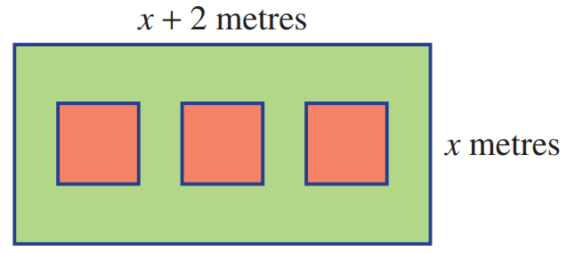
- A backyard, rectangular in area, has a length 2 metres more than its width ($x$ metres).
Inside the rectangle are three square paved areas each of area 5 m² as shown.
The remaining area is lawn.
Find an expression for the:
  - total backyard area

$$x^{2}+2x$$
  - area of lawn in expanded form

$$x^{2}+2x-15$$
  - area of lawn in factorised form

$$\left(x+5\right)\left(x-3\right)$$
- Factorise $25x^{2}+70x+48$Hint: let $a=5x$

$$\left(5x+6\right)\left(5x+8\right)$$

